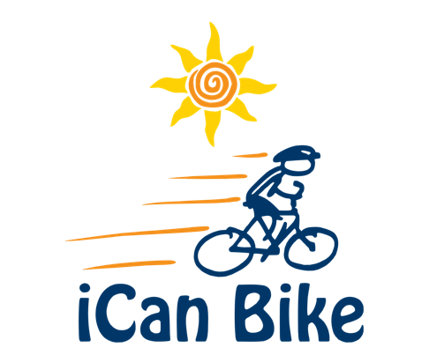
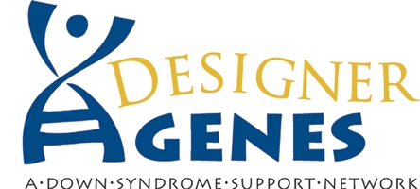

iCan Bike Bismarck July 26-30, 2021 at VFW Sports Arena

The goal of camp is to teach individuals with disabilities to ride a two-wheel bicycle and become lifelong independent riders. We need your help to make this program a big success. The iCan Shine staff are highly trained, and they supply the custom-built adapted bike equipment needed for camp. By making a tax-deductible donation, you can ensure that we have the funds we need to conduct the camp and keep the fees for the families of participants to a minimum. We offer scholarships for those families with financial need and we also provide a helmet for each camper/rider ($40/each).

- $3,000 - Platinum Sponsor- Name/logo on banner, t-shirts,
website award certificates, market via PSA, Radio and other.

- $1,000 - Gold Sponsor- Name/logo on banner, t-shirts, website,
and award certificates

- $500 - Silver Sponsor- Name/logo on banner, T-shirts, and award certificates

- $250 - Bronze Sponsor- Name/logo banner

- $100 - Rider Sponsor- 1 participant

- Choose an amount that fits your budget: $ _____________

Volunteers needed. Each camper receives 2: 1 volunteer assistance during their daily 75-minute sessions. Depending on individual volunteer time constraints, this translates to a lot of volunteers. Please contact Rachael Buss at Rachael.buss@annecenter.org or 701-263-4556 if you have questions or can offer volunteer support.

For questions about sponsoring, please contact Roxane Romanick at 701-391-7421
or info@designergenesnd.com.

Please include your check, made payable to Designer Genes of North Dakota, Inc., along with this form (checking the corresponding sponsor option of choice) and mail to: Designer Genes of North Dakota, Inc. 1500 E. Capitol Ave., Ste. 204 Bismarck, ND 58501

This is a life-changing opportunity for our campers - thank you for making it possible!

icanshine.org/ican-bike-bismarck-nd/

